Booking Form – 2023 St Patrick’s Eve Dinner v1

>>>>> ENTRY BY PREPAID BOOKING ONLY <<<<<

CLOSING DATE: Friday 3rd March 2023 (Strictly)

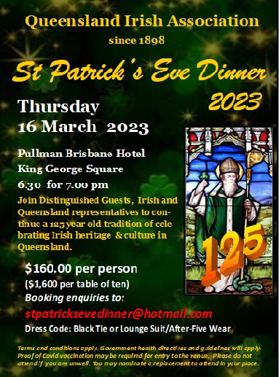
I wish to attend the 2023 St Patrick’s Eve Dinner
at the Pullman Hotel Brisbane, King George Square
Thursday 16th March 2023
at 6.30pm for 7.00pm.

Cost per person $160.00
EFT (preferred method) / Direct Deposit:
Queensland Irish Association
BSB: 014-010 Account: 411572417
Reference: Your surname - as reference

Cheques payable to “Queensland Irish Association”
Post to: PO Box 12745 GEORGE STREET QLD 4003

NAME ____________________________________________

ADDRESS ______________________________________________________

______________________________________________________

PHONE __________________________________________

EMAIL __________________________________________

Terms and conditions apply. Government health directives and guidelines will apply. Proof of Covid vaccination may be required for entry to the venue. Please do not attend if you are unwell. You may nominate a replacement to attend in your place.

SURNAME GIVEN NAME GROUP
1._____________________________________________________________
2._____________________________________________________________
3._____________________________________________________________
4._____________________________________________________________
5._____________________________________________________________
6._____________________________________________________________
7._____________________________________________________________
8._____________________________________________________________
9._____________________________________________________________
10.____________________________________________________________
Please return completed booking form to: stpatricksevedinner@hotmail.com

