Booking Form - 2026 St Patrick’s Eve Dinner v1_1

>>>>>ENTRY BY PREPAID BOOKING ONLY<<<<<
CLOSING DATE: Monday 2nd March 2026 (Strictly)

Complete this form and email to:stpatricksevedinner@hotmail.com

I wish to attend the 2026 St Patrick’s Eve Dinner at
Brisbane City Hall Main Auditorium
MONDAY 16th March 2026 at 6.00 for 6.45pm.
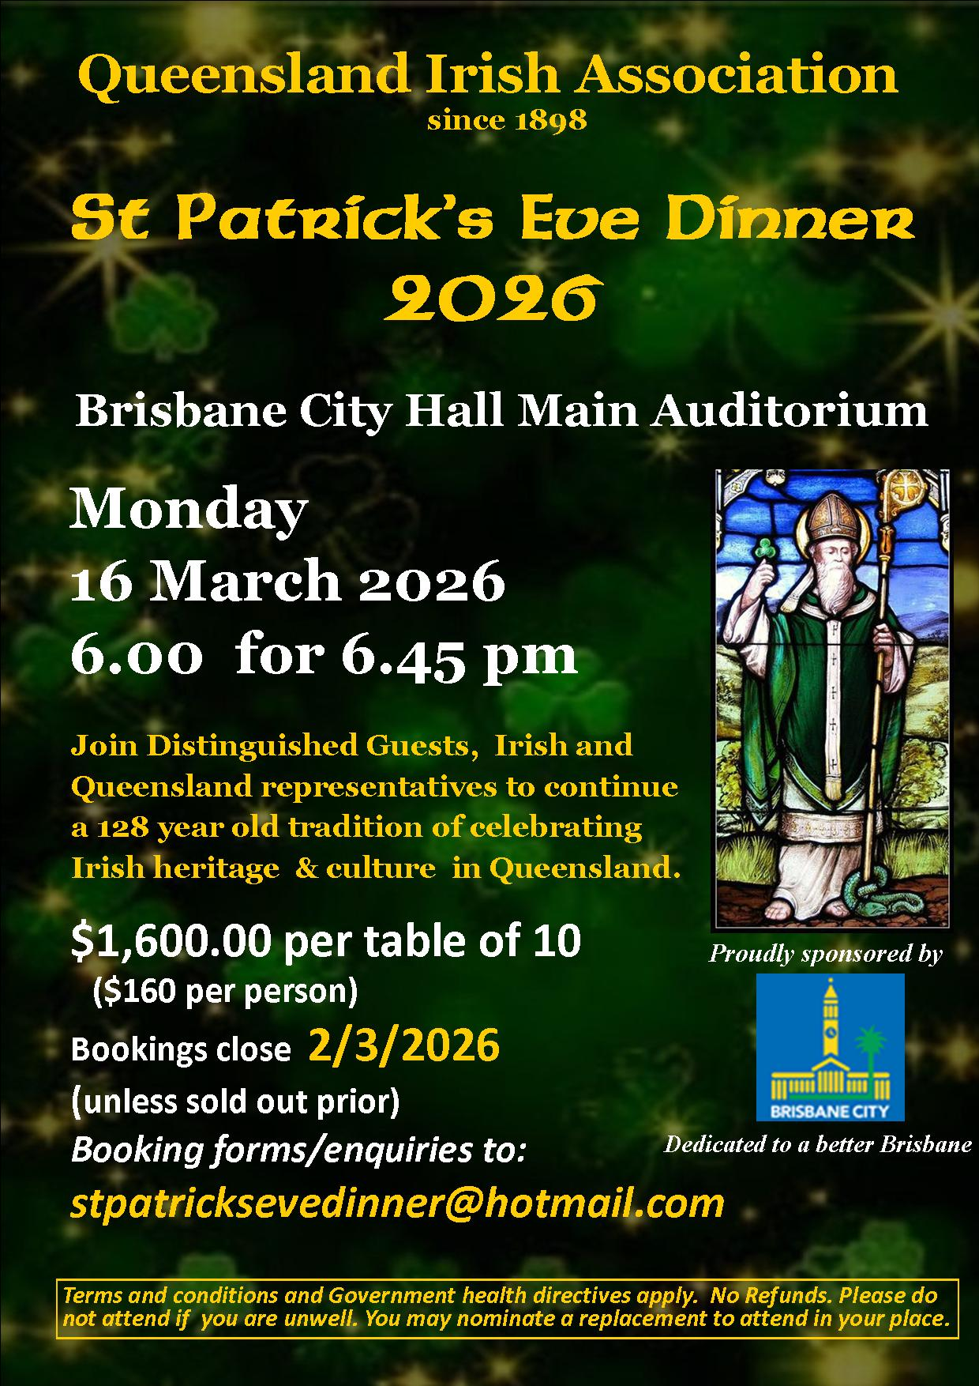

Payment $1,600 per table of ten ($160 per person)
 EFT (preferred method) / Direct Deposit:
Queensland Irish Association
BSB: 084-034 Account: 920759183
Payment Reference (eg Your surname and postcode)

(insert here)

 Cheques payable to “Queensland Irish Association”
Post to: PO Box 12745 GEORGE STREET QLD 4003

NAME __________________________________________

ADDRESS __________________________________________

__________________________________________

PHONE __________________________________________

EMAIL __________________________________________

Terms and conditions apply. Please do not attend if you are unwell.
No refunds. You may nominate a replacement to attend in your place.

Please return completed booking form to: stpatricksevedinner@hotmail.com

GROUP LEADER/TABLE CAPTAIN

SURNAME GIVEN NAME DIETARY

1._____________________________________________________________
2._____________________________________________________________
3._____________________________________________________________
4._____________________________________________________________
5._____________________________________________________________
6._____________________________________________________________
7._____________________________________________________________
8._____________________________________________________________
9._____________________________________________________________
10.____________________________________________________________

