**Booking Form – 2025 St Patrick’s Eve Dinner v3_1**

# >>>>> ENTRY BY PREPAID BOOKING ONLY <<<<<

CLOSING DATE: Wednesday 5th March 2025 (Strictly)

# 

**Complete this form and email to:** ***stpatricksevedinner@hotmail.com***

I wish to attend the **2025 St Patrick’s Eve Dinner** at

**Brisbane City Hall Main Auditorium**

**SUNDAY 16th March 2025** **at 6.00 for 6.45pm*.***

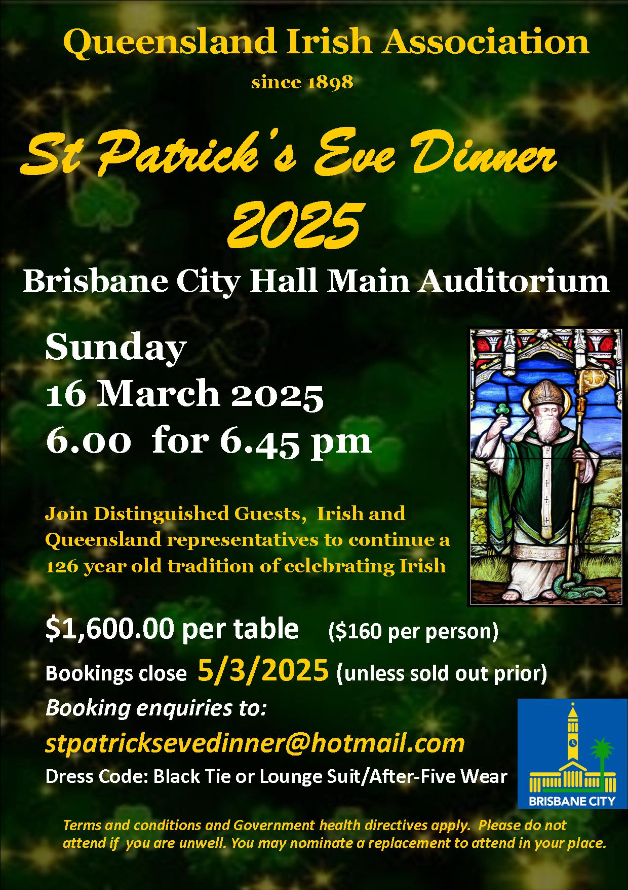

**Payment** **$1,600 per table ($160 per person)**

** EFT (preferred method) / Direct Deposit:**

**Queensland Irish Association**

**BSB: 084-034 Account: 920759183**

**Reference: eg Your surname and postcode**

**(insert here)**

** Cheques payable to “Queensland Irish Association”**

**Post to: PO Box 12745 GEORGE STREET QLD 4003**

**NAME** __________________________________________

## **ADDRESS** __________________________________________

### __________________________________________

### PHONE __________________________________________

### EMAIL __________________________________________

**Terms and conditions apply. Please do not attend if you are unwell.**

**No refunds. You may nominate a replacement to attend in your place.**

### *Please return completed booking form to: stpatricksevedinner@hotmail.com*

### GROUP LEADER/TABLE CAPTAIN

### SURNAME GIVEN NAME DIETARY

# 1.____ _________________________________________________________

2._____________________________________________________________

3._____________________________________________________________

4._____________________________________________________________

5._____________________________________________________________

6._____________________________________________________________

7._____________________________________________________________

8._____________________________________________________________

9._____________________________________________________________

10.____________________________________________________________