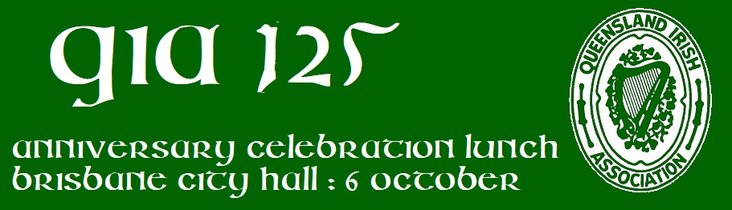
Queensland Irish Association (since 1898)
INVITES YOU to JOIN US for our 125th ANNIVERSARY CELEBRATION LUNCH
Where ? Ithaca Auditorium, Brisbane City Hall King George Square, Brisbane
When ? Friday 6th October 2023 - NOON
Price ? $800 for a Table of ten ($80 single)
What's included ? Two Course Meal and Welcome Drink, Tea, Coffee and a Cash Bar
What else ? Irish Entertainment and Sing-along
PLUS... ! Raffle Prizes and the QIA History Book will be on sale
DRESS: Smart casual
BOOKING INFO : Please email completed booking form and payment confirmation to:
irisheventsbne@hotmail.com
PAYMENT : Direct Bank Transfer using FULL NAME as reference
Account Name: Queensland Irish Association
BSB: 014-010
Account: 411572417
OTHER CONTACTS : enquiries@queenslandirish.com(07) 3067 3064
R.S.V.P – BOOKINGS ARE LIMITED AND CLOSE THURSDAY 28th SEPTEMBER IF NOT FILLED EARLIER
Open this form as a Word document, edit with your info, save as doc, docx or pdf format file and email file to irisheventsbne@hotmail.com
Your Details Are -
Group Leader : __________________________ Phone : ____________________________
Address : ________________________________ Email : ____________________________
Who is attending ?
Name _______________________________ Name _________________________________
Name _______________________________ Name _________________________________
Name _______________________________ Name _________________________________
Name _______________________________ Name _________________________________
Name _______________________________ Name _________________________________
NOTE - Tickets are not issued. Table allocations are provided at Entry/ Event Check In
Please specify if any dietary requirements are required
- QIA 125th Anniversary Lunch 2023 - Booking v2

